Knowledge Management Vision in Korea

By

O, Gangtak¹
Dept. of IT Support and Planning, Information Technology Services Division, National Computerization Agency
Sejongro-Daewoo Bldg.167, Naesu-Dong Jongro-Gu, Seoul Korea 110-070
Tel: +82-2-398-9043, Fax: +82-2-733-6038

Introduction

The world is underway a paradigmatic change from the industrial age to the information and knowledge age. Now knowledge and information are regarded as the most important resources. So it is said that the 21st century will hinge on knowledge and information. In response, a number of countries have been investing a vast sums of governmental fund in ‘knowledge and information management’ projects or ‘electronic government’ projects. The projects include innovative programs to meet the need for the improved information and knowledge usage in the public sector. Now sharing information and knowledge across organizational boundaries has already become commonplace and a crucial issue in reinventing government.
In Korea the issue has been emphasized since the early 1990. On March 1999, the “Cyber Korea 21” was issued as a blueprint for a knowledge-based information nation. Furthermore, President Kim Dae-Jung unveiled a nation-wide plan or project to change the quality, nature, and flow of information and knowledge in his New Year’s message this year. And the Act of Knowledge & Information Resources Management and its action plan were recently passed the congress and have came into force on July 29th, 2000. The Act and its action plan gave our organization, the NCA(National Computerization Agency) the mission to make the national master plan and annual action plan of knowledge and information resources management(K&IRM) and implement them. Before discussing the specifies of K&IRM project in Korea, the roles and missions of the NCA are explained in advance.

A Brief of NCA

The NCA was established in 1987 funded by the Ministry of Information and Communication so as to provide information and IT-related services for the public sector, as well as for the private sector. Since then, the NCA has made efforts so that government and private organizations can make the best use of the new and exciting opportunities provided by ITs. The organization has contributed to building a knowledge-based information society in Korea. The missions of it are as follows:
• to provide expertise in preparing and implementing the annual action plans for
national information promotion.
• to construct KII(Korea Information Infrastructure) and to provide extensive
information sharing services among agencies within government. through the KII.
• to establish IT standards
• to evaluate and audit IT projects
• to manage Knowledge and information as national resources.
• to offer consultation on and development of IT policy of each agency within
government. etc.
For more details , you can visit the NCA homepage(http://www.nca.or.kr)

Description of K&IRM Project in Korea

Based on ‘Cyber Korea 2000’ and ‘Act of Knowledge and Information Resources Management and its Action Plan’, the NCA has launched a national-level K&IRM project to better manage the knowledge and information as national resources since the late 1999. The primary objectives of the project are:
• to digitize all valuable and useful knowledge and information to preserve and use
at a national-level and build an integrated national knowledge bases or repositories.
• to develop a National Knowledge and Information Portal System(NK&IPS) to
integrate all digitized knowledge and information.(See figure 1 below)
• to enable everyone(right person) to easily get right knowledge and information at
right time through a high-speed internet: 3R
To accomplish these objectives, around US$ 550million governmental fund is planned to be spent by 2002. Of US$ 550million, about 80% will be spent on a lot of projects to digitize most of the knowledge and information in the following fields:
• education and R&D
• scientific technology
• national heritage and history
• culture and art
• English Database for national PR
The rest will be scheduled to be used on the development and implementation of the NK&IPS .
We expect that the benefits of the successfully-conducted K&IRM projects will be immense. The benefits include:
• more reliable and systematic management over the NKIR
• more and better accessibility to NKIR that people, as well as public officers
consider important to the conduct of their businesses..
• more extensive the NKIR sharing among the agencies within government and
between government agencies and private and non-profit organizations.
• enhanced people’s quality of life
• to the end enhanced competency to use national knowledge assets
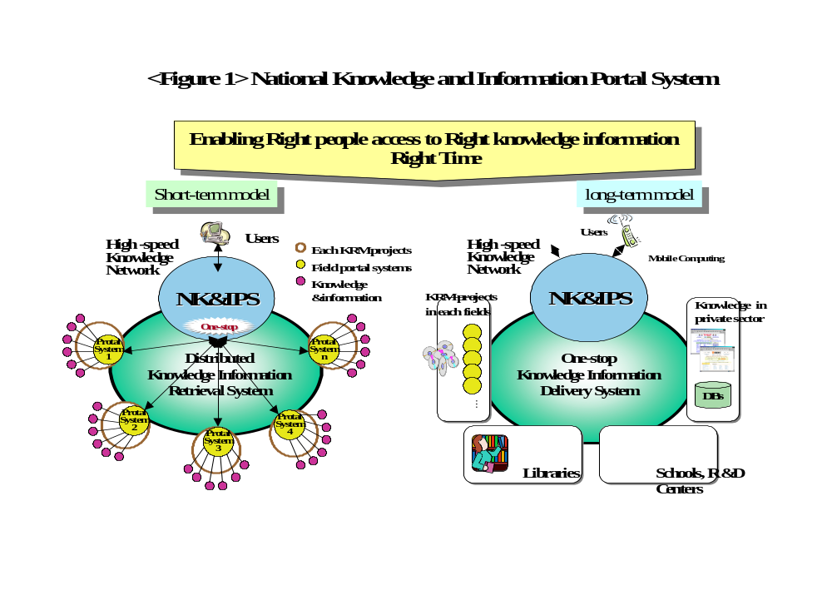
In addition, the NCA organized a task force team for the purpose of supporting the projects. The team composed of 5 senior researchers, who have various backgrounds such as computer science, public and business management, politics, and library science, etc. They have already completed the guidelines for managing knowledge resources to be used by the public officers. In the near future they are planning to design a contingent model of evaluating the knowledge resource management applicable in the public sector.

Conclusions and Proposals

The implementation of the NK&IRM projects is strongly influenced by the capabilities of existing information technologies, though information technologies are not the whole solution to a nation’s knowledge management needs. In this respect, this small workshop on the digital libraries provides very meaningful implication to national knowledge management. Especially, it is likely that technologies and research issues proposed by the researchers on the US-Korea Join workshop are very important:
• queries, searching, and retrieval : CLIR, query models/languages for semi-
structured information, caching, remembering, reusing, analyzing old queries/results.
• digital library representation issue : handling semi-structured data with wrappers,
metadata frameworks and registries, MPEG-7.
• digital library applications : developing digital library services in the open archives
initiative, content conversions.
We have lots of documents to be digitized. Until recently many key entry persons have been put in digitizing them, because we didn’t have technical solutions to solve excessive cost of document digitization. Thus, we try to find a new approach, a text automatic recognition system, to solve the problem. To accomplish the K&IRM project, we need to conduct the collaborative or joint researches to develop technologies related to knowledge management systems.

Thanks a lot for listening

-------------------------------------------------------------------------------------------------------
- He is a senior researcher of the NCA. He received Ph. D degree from Hankuk University of Foreign Studies. His major is public management information systems. He is in interested in the evaluation of IT effectiveness and knowledge management. Tel.: +82-2-398-9043, E-Mail: okt@nca.or.kr.

